Task-1

Network Intrusion Detection System (NIDS) Project Report
  - Prepared By: Yuva Ritheesh kumar.S
  - project Title: setup of Network Intrusion detection system
  - company: INFOTACT Solutions

1. Introduction of snort
Snort is a free and open-source Network Intrusion Detection System (NIDS) developed by Martin Roesch and now maintained by Cisco. It monitors network traffic in real time and uses rules to detect suspicious activities such as scans, brute-force attacks, and malware communication. Snort can run in different modes like packet sniffer, traffic logger, or intrusion detection system. Because it is lightweight, flexible, and supports custom rules, Snort is widely used in both organizations and labs to learn, test, and improve network security

2. Lab Setup
• VirtualBox/VMware for virtualization
• Attacker VM: Kali Linux (Nmap, Hydra, Metasploit)
• Victim VM: Ubuntu Server with Snort
• Tools used: Nmap, Hydra, Nikto, Wireshark

3. Installation snort

Step 1: Install and configure Snort
On Kali Linux, Snort can be installed directly from the package repository.
- Run the following commands in the terminal:
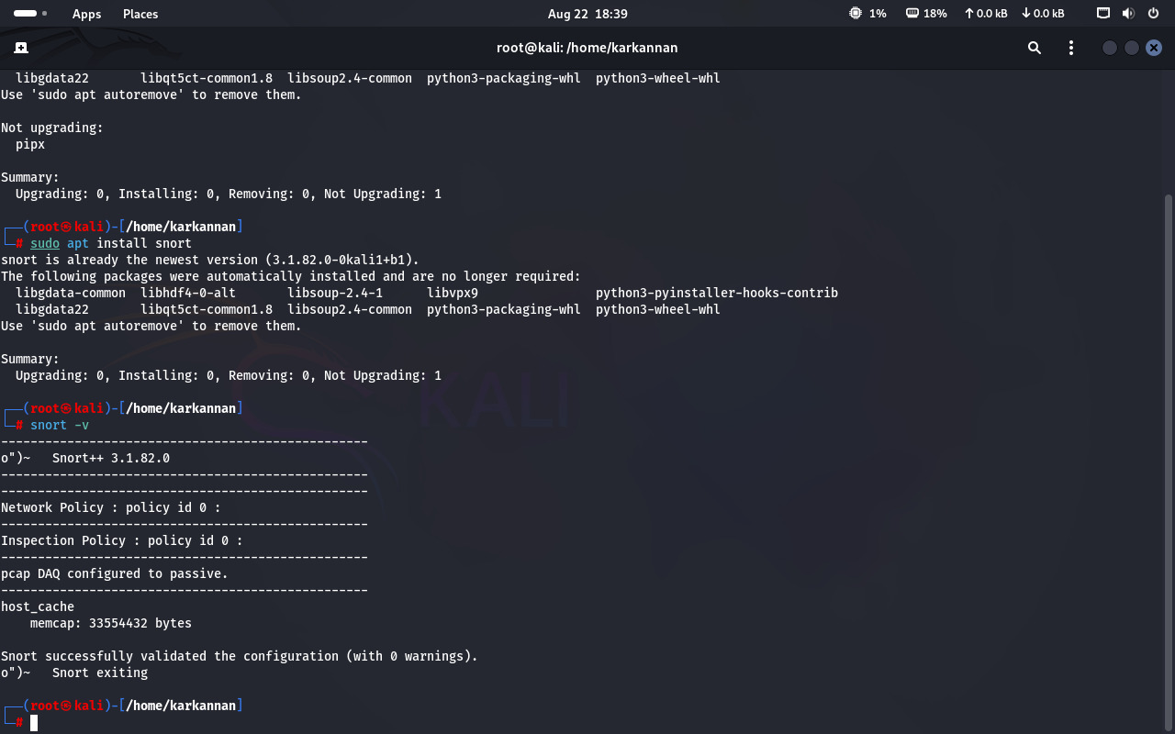
sudo apt update and sudo apt install -y snort
After installation, verify Snort’s version with: snort -V
Result:
- Snort is successfully installed.
- Version information is displayed.
- Configuration files are located at cd /etc/snort/ (main config: snort.conf, local rules: local.rules).

Exploring Snort Rule Files
- After installing Snort, all the rule files are stored in: /etc/snort/rules/
- I used the commands: cd /etc/snort,cd rules,ls
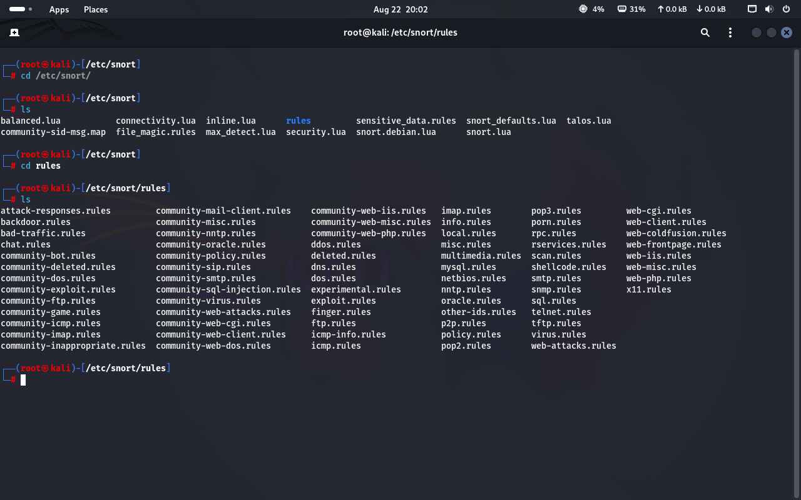
This shows many .rules files. Each file contains rules for detecting different types of attacks. For example:
icmp.rules → Detects ping traffic.
scan.rules → Detects port scanning (like Nmap).
ftp.rules → Monitors FTP traffic.
web-attacks.rules → Detects web-based attacks.
local.rules → File where we add our own custom rules.
Result: Snort installation is successful, and rule files are ready for use.

Adding a Custom Rule in Snort
Snort allows security analysts to create custom rules that can detect specific traffic patterns or attacks. These rules are usually stored inside the file local.rules, which is meant for user-defined rules. By adding a new rule, we can make Snort detect traffic such as ICMP pings, port scans, or brute-force attempts.

Step 1: Open the local.rules file
To add a new rule, open the local.rules file in a text editor.By using the command: sudo nano /etc/snort/rules/local.rules
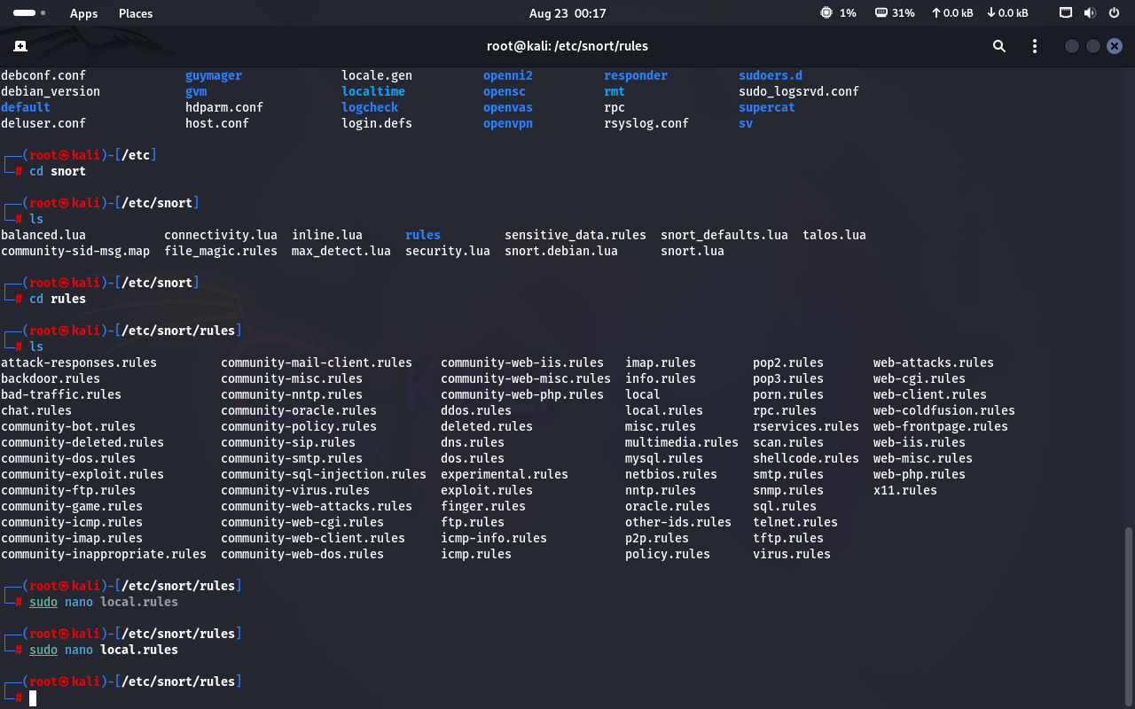

Step 2: Add a custom ICMP rule
- Inside the file, add the following rule:

alert icmp any any -> any any (msg:"ICMP test detected"; sid:1000001; rev:1;)

Explanation of the rule:
- alert → Action to be taken (generate an alert).
- icmp → Protocol (this rule is for ICMP traffic, like ping).
- any any -> any any → Source IP/port to destination IP/port (here it applies to all).
- msg:"ICMP test detected" → Custom alert message that will be shown when the rule is triggered.
- sid:1000001 → Snort ID, a unique identifier for this rule.
- rev:1 → Revision number of the rule.
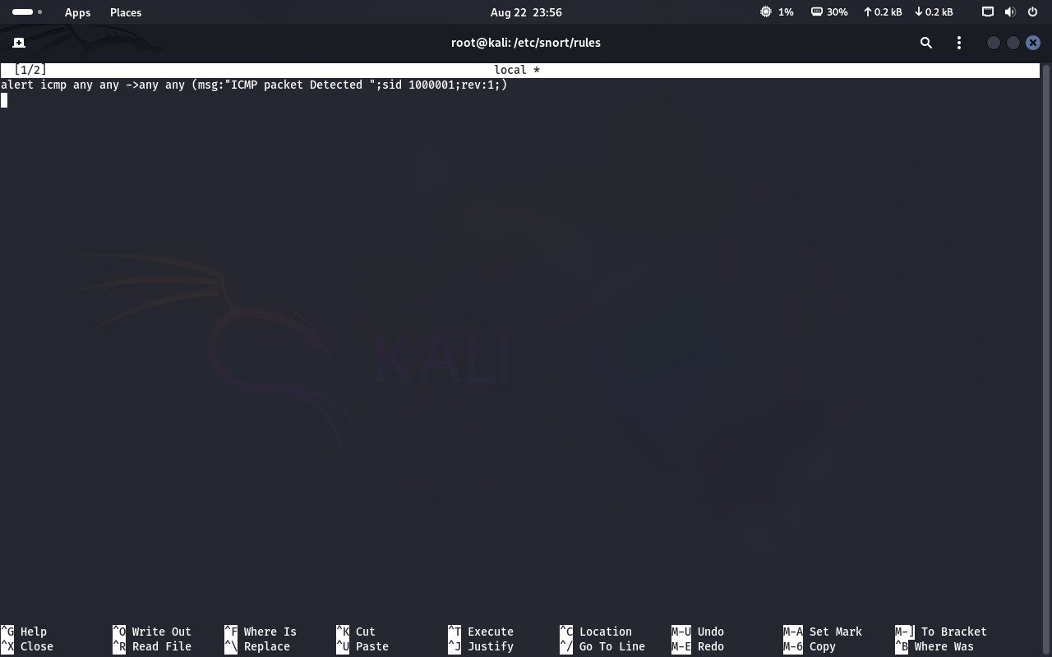

Step 3: Save and exit

Press CTRL + O → ENTER → CTRL + X to save and close the file.
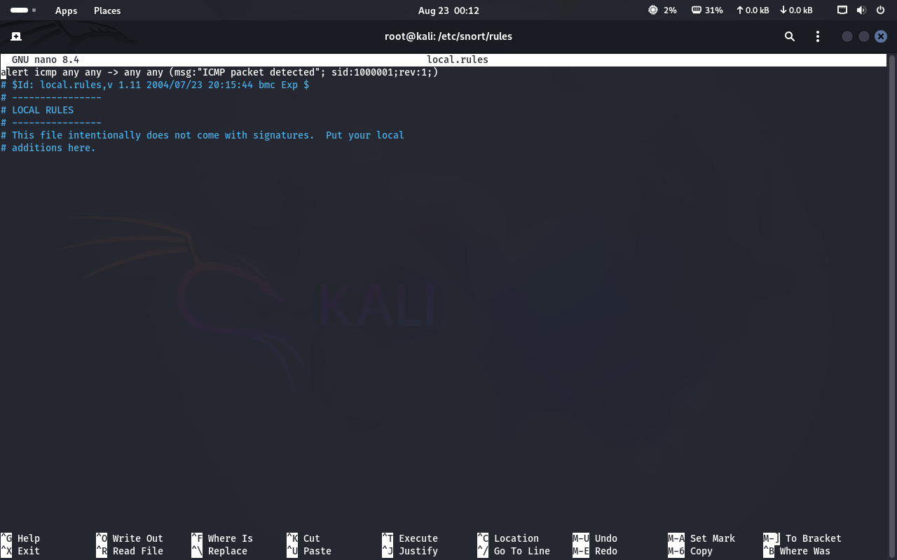

Configuring Snort to use local rules
- Configuring Snort to Use Local Rules Cmd: sudo nano snort.lua
- The Snort configuration was updated in the snort.lua file:
{
rules = [[
include /etc/snort/rules/local.rules ]],
}
- At the fifth configuration point, the following directive was added to ensure Snort loads the local rules:
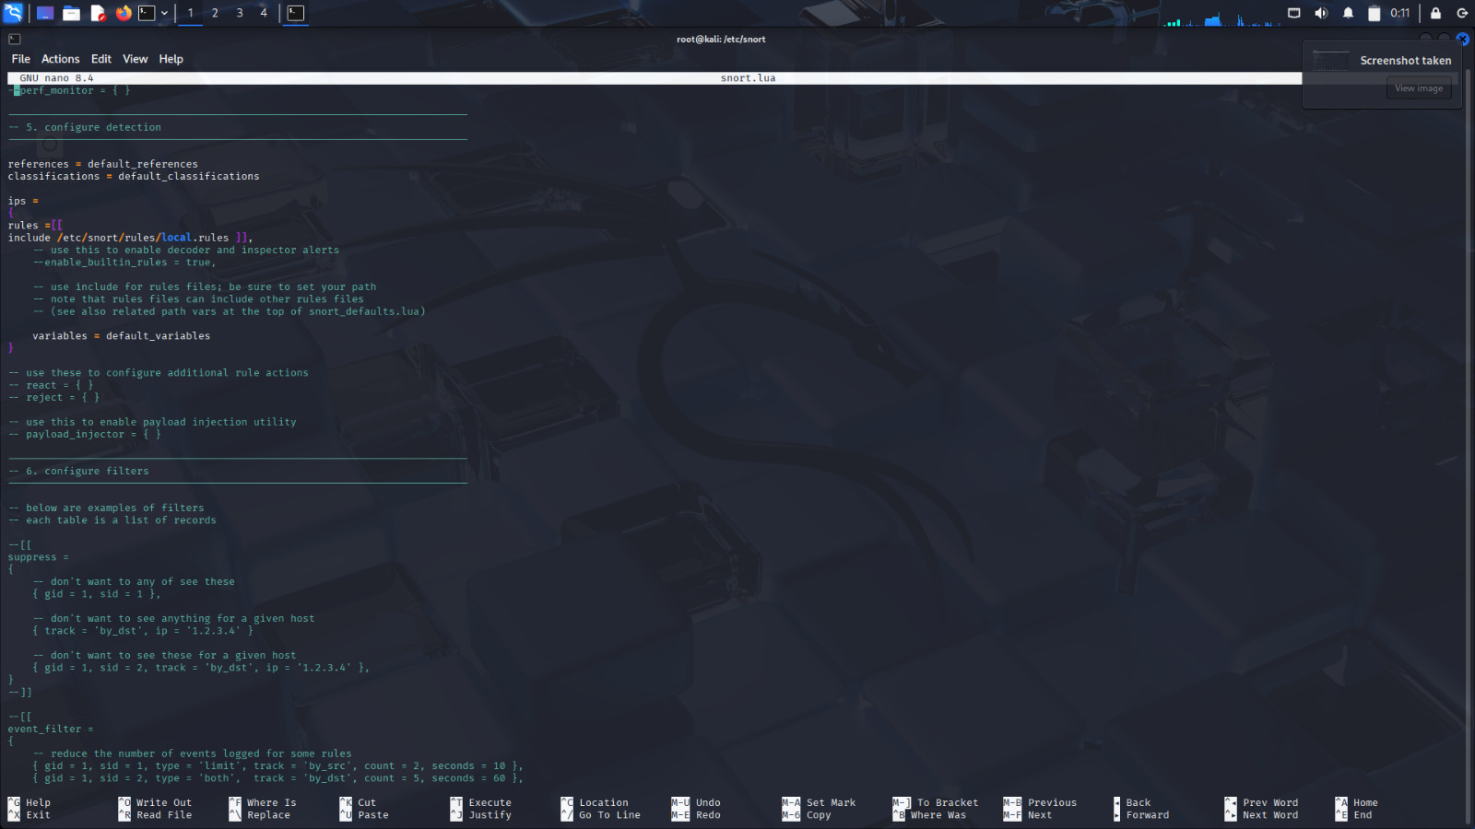
Running Snort with Configured Rules
- Cmd: sudo snort -c /etc/snort/snort.lua -i eth0 -A alert_fast
- To activate Snort with the configured rules, the following command was executed:
- c specifies the configuration file.
- i eth0 sets the network interface to monitor.
- A alert_fast displays alerts quickly in the console.

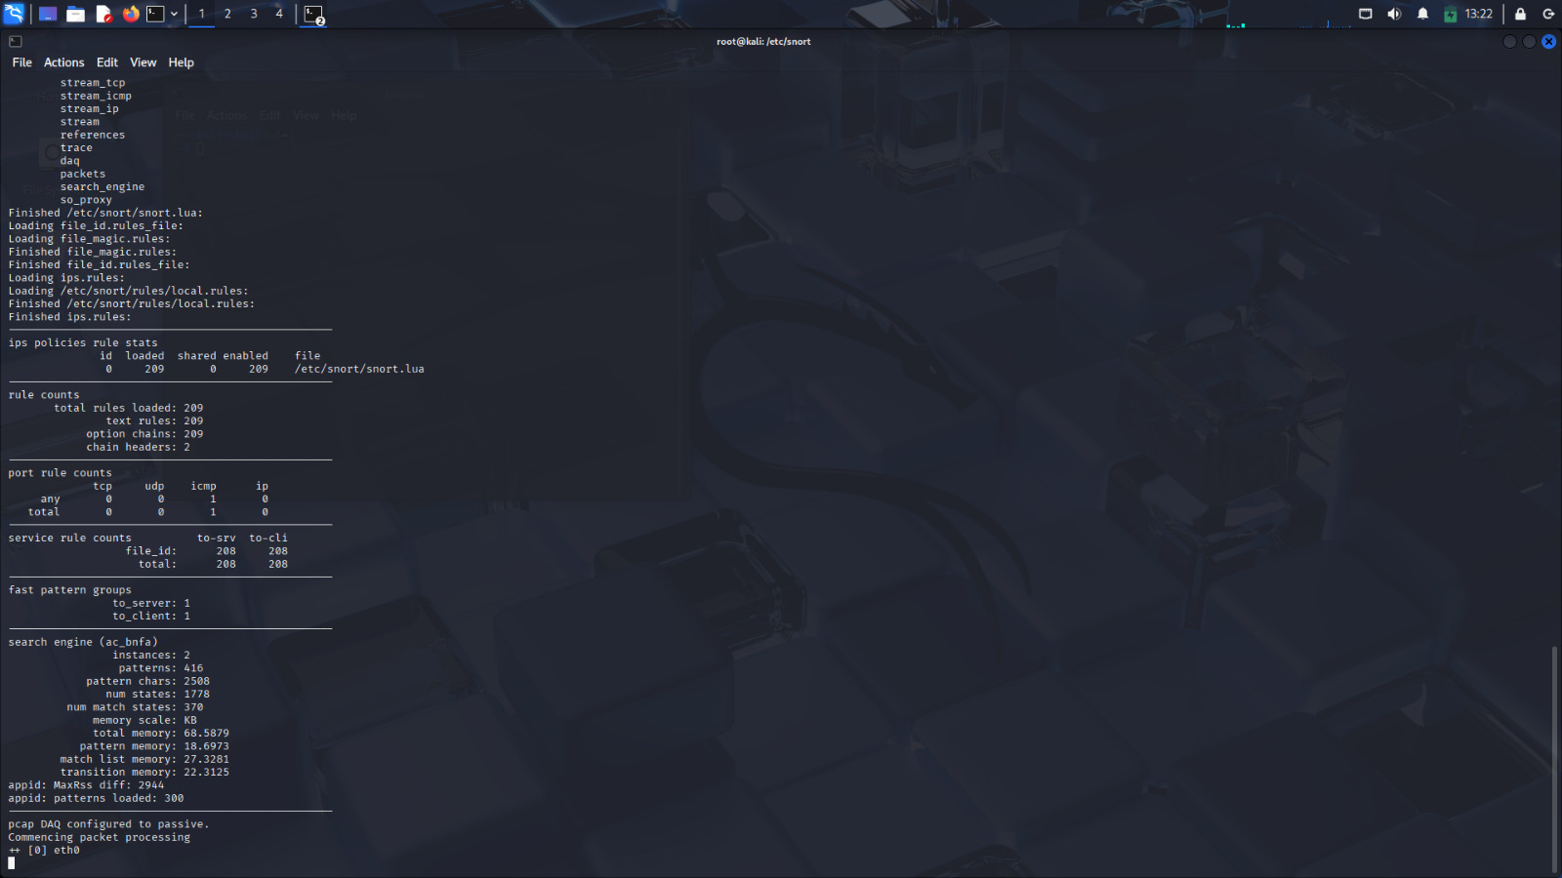

Testing the NIDS with ICMP Traffic
- A second terminal window was opened to simulate external network activity.
- A ping test was initiated to an external host using the command:
ping 8.8.8.8
- The ping command generated a series of ICMP Echo Request packets destined for the IP 8.8.8.8.
- Snort was actively monitoring the network interface during this activity.
- A custom ICMP detection rule had already been configured in the local.rules file (SID: 1000001).
- As soon as the ICMP Echo Request packets were transmitted, Snort inspected the traffic against its ruleset.
- The configured ICMP rule matched the traffic pattern (ICMP type 8).
- Snort immediately generated an alert indicating the detection of ICMP ping activity.
- The alert was logged in the alert_fast.txt file located in /var/log/snort/.
- This confirmed that Snort was functioning correctly and capable of detecting ICMP traffic as intended
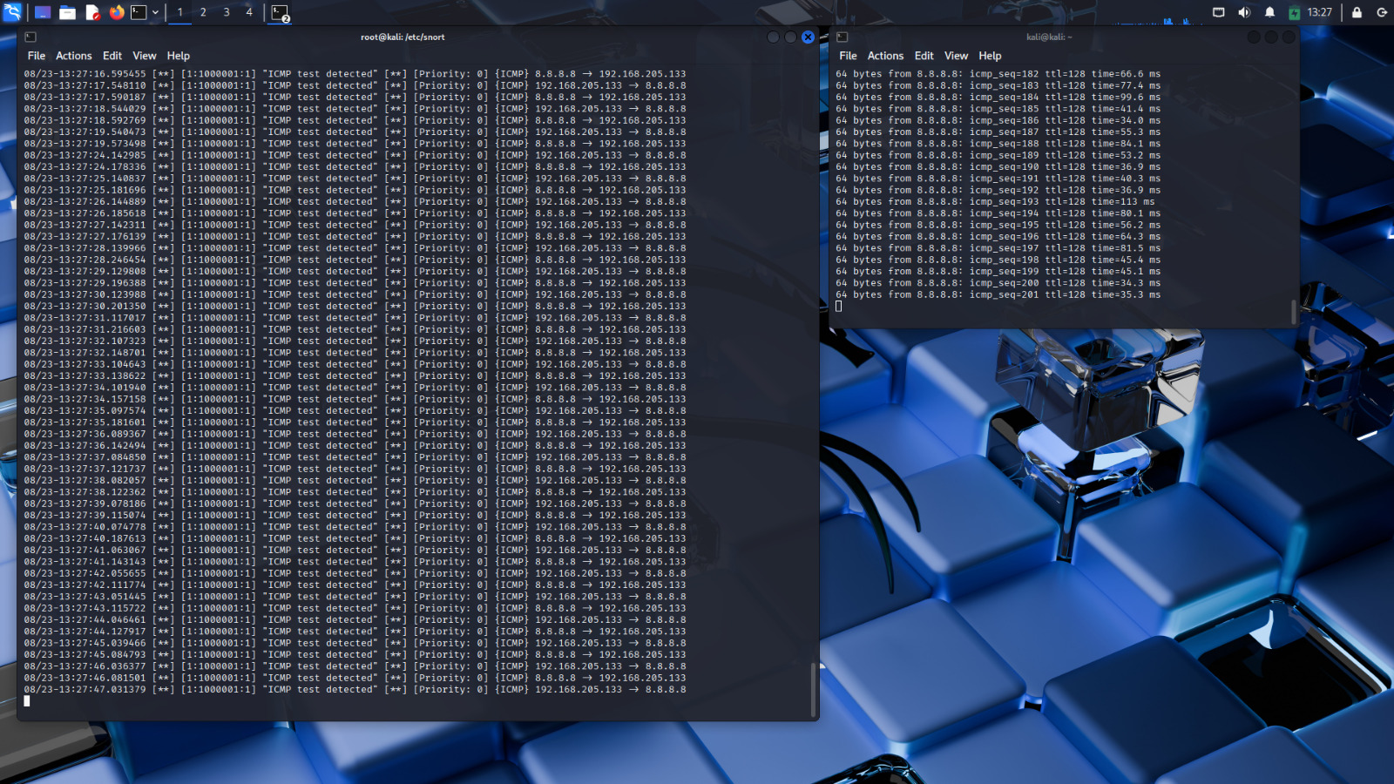Conclusion
In this lab, Snort was successfully installed, configured, and tested on Kali Linux. A custom rule set was created in local.rules, and Snort was pointed to this file through the snort.lua configuration. The IDS was then tested with different types of traffic, including ICMP pings and Nmap scanning techniques.

